GSC “Crawled – Currently Not Indexed”
Investigation & Validation Guide
LEDSone.co.uk — Internal SEO Handover / SOP

1. Purpose
This guide explains how to investigate the Google Search Console (GSC) Page Indexing issue “Crawled – currently not indexed” safely and consistently. It is written so a new SEO team member can understand the report, test representative URLs, distinguish historical validation data from current URL status, and know when to take action.

2. What “Crawled – currently not indexed” means
Google has crawled the URL successfully, but the URL is not currently included in Google's index. This status does not by itself prove that the URL is technically broken. Google may decide not to index a URL for many reasons, and the Page Indexing report can lag behind the current status shown by URL Inspection.

3. Current LEDSone report snapshot
GSC item | Observed value
Current issue | Crawled – currently not indexed
Affected pages | 8,633 (8.63K shown)
Report last update | 18 Sep 2026
Old validation | Started 5 Aug 2026; failed 8 Aug 2026
Old validation failed | 1,888
Old validation pending | 6,745

4. Important distinction: report vs URL Inspection
The Page Indexing report is a batch report with a Last update date. URL Inspection can show a more current state for an individual URL. Therefore, a URL can still appear in an older “Crawled – currently not indexed” report while URL Inspection now says “URL is on Google.”
In this investigation, four sampled URLs from the report were checked and all four were currently indexed. This is evidence that the report should not be interpreted as proof that every listed URL is still unindexed.

5. Step-by-step investigation SOP
Step 1 — Open the current Page Indexing report
GSC → Indexing → Pages. Record the count for “Crawled – currently not indexed” and the report’s Last update date.
Step 2 — Open the issue
Click “Crawled – currently not indexed” and review the affected-page count and examples.
Step 3 — Choose representative URLs
Do not request indexing for thousands of URLs. Select examples from different URL patterns, such as /pl/, /es/, /nl/, product URLs, collection/product URLs, and parameter URLs.
Step 4 — Inspect each URL
Use GSC → URL Inspection. First check whether the URL is currently on Google.
Step 5 — If URL is indexed
Record it as currently resolved/healthy for that sample. Do not request indexing just because the old report contains it.
Step 6 — If URL is not indexed
Expand Page indexing and record the exact reason, crawl status, indexing allowed status, user-declared canonical and Google-selected canonical.
Step 7 — Check the live page when needed
Open the URL, check response/redirect behavior, canonical, robots/noindex, and relevant international signals.
Step 8 — Compare patterns
After several samples, determine whether the issue is one common pattern or several different patterns.
Step 9 — Decide on validation
Only start a new validation after confirming there is a current issue worth validating. Do not use Start New Validation simply because an old validation says Failed.
Step 10 — Monitor
After any verified fix, allow Google to recrawl and monitor the report’s Last update date and representative URL Inspection results.

6. Testing example — sample 1
Example URL selected from the old validation list:
https://ledsone.co.uk/pl/products/10m-2-core-twisted-electric-cable-teak-black-color-fabric-0-75mm-4890
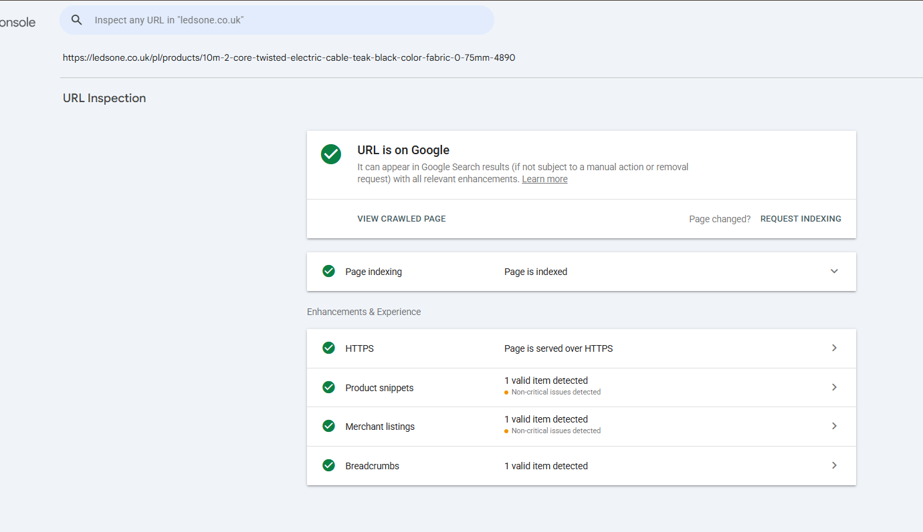
Result: URL is on Google; Page is indexed.
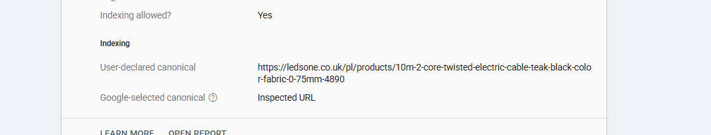
Canonical result: user-declared canonical is the inspected product URL and Google-selected canonical is the inspected URL.

7. Testing example — sample 2
Example URL containing a collection/product path and variant parameter was inspected.
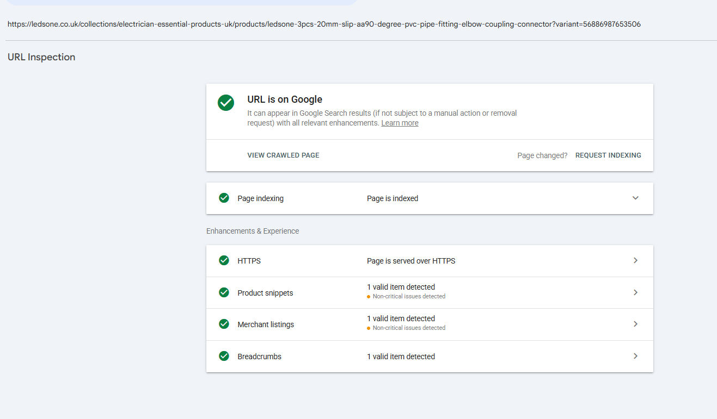
Result: URL is on Google and Page is indexed. This shows that a URL containing a variant parameter is not automatically a current indexing failure.

8. Testing example — sample 3
Example /es/ product URL from the report.
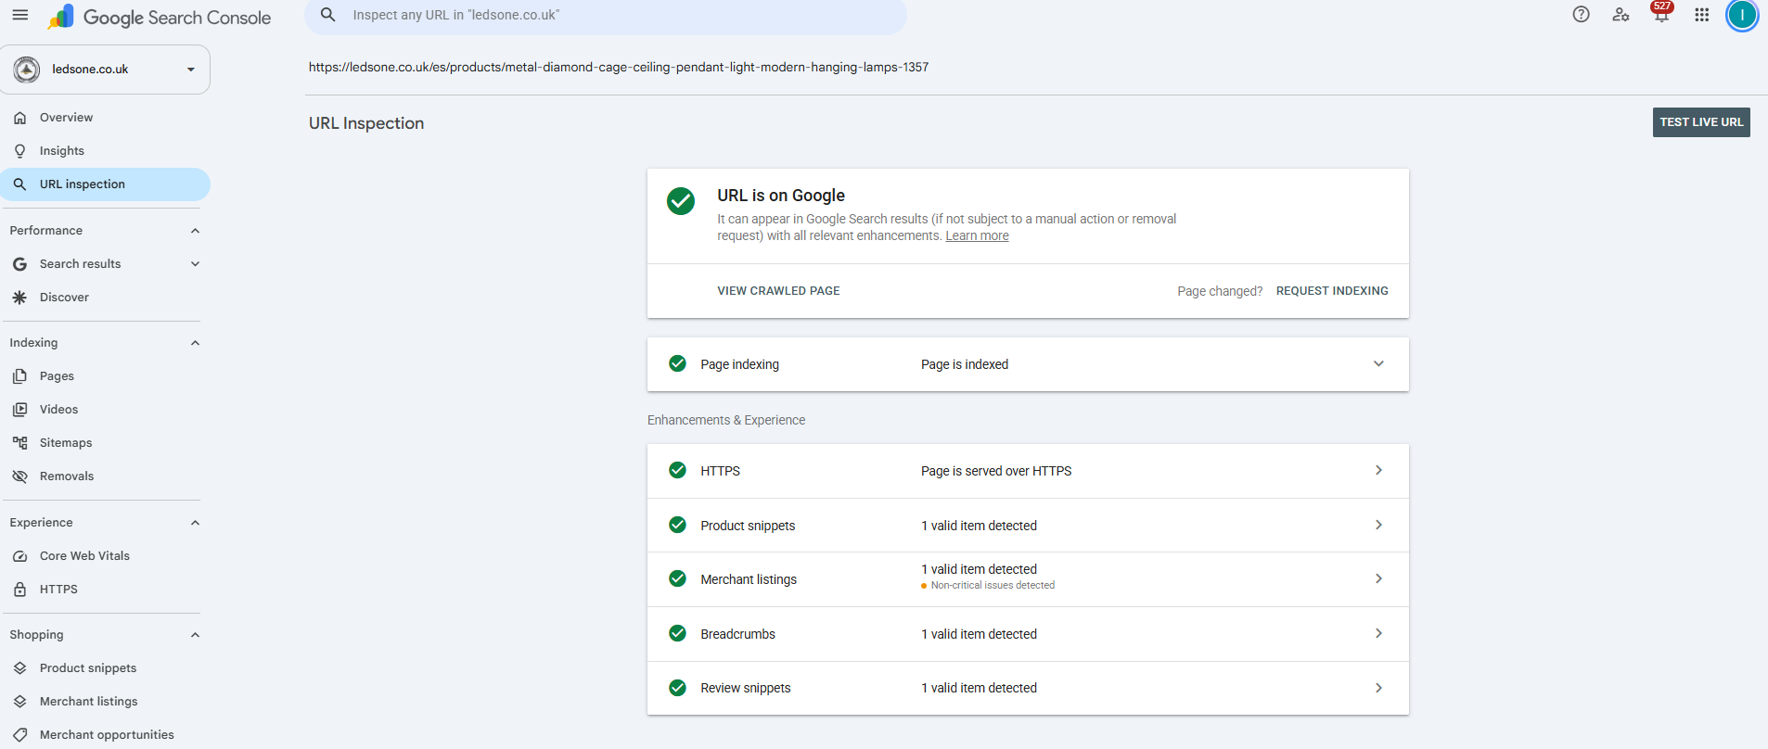
Result: URL is on Google and Page is indexed.

9. Testing example — sample 4
Example /nl/ product URL from the current 8,633 report.
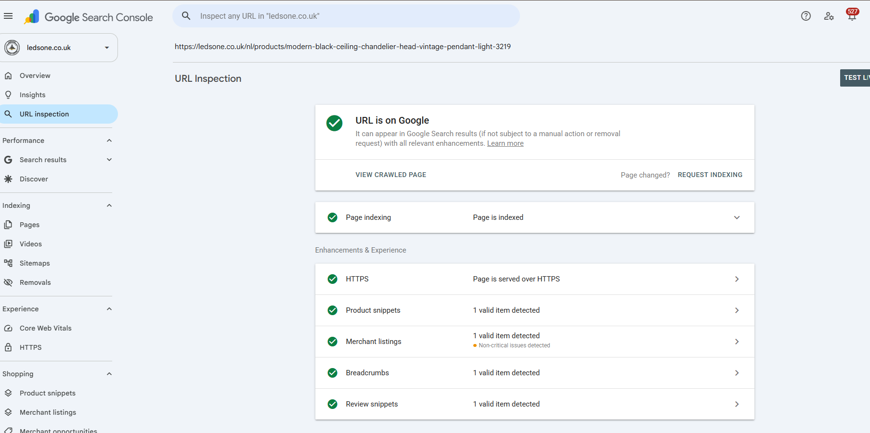
Result: URL is on Google and Page is indexed.

10. Current report evidence
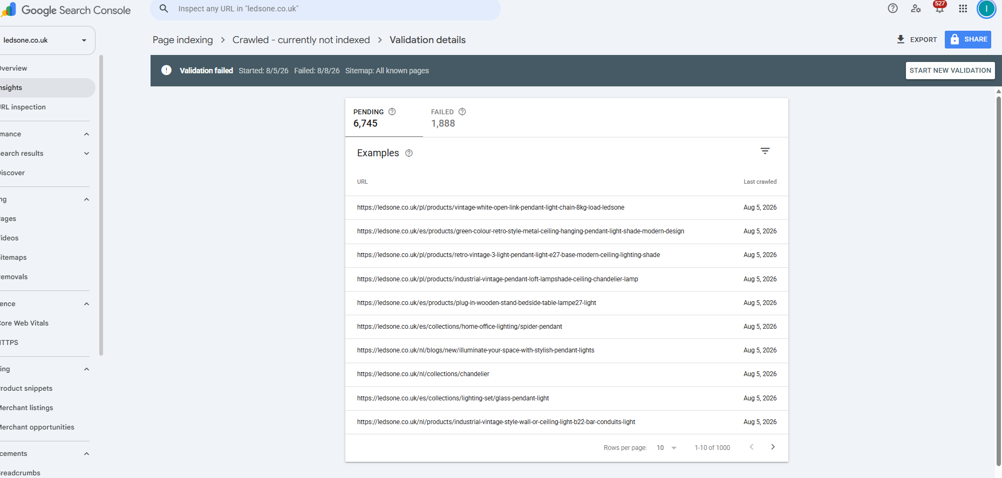
The main Page Indexing report shows 8,633 Crawled – currently not indexed, alongside other exclusion categories.
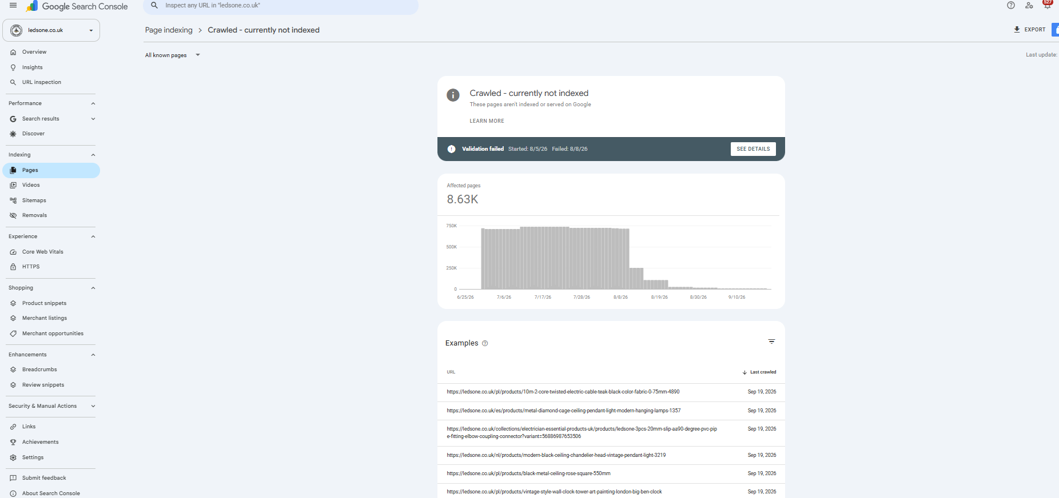
The detailed report shows the 8.63K affected pages and example URLs.
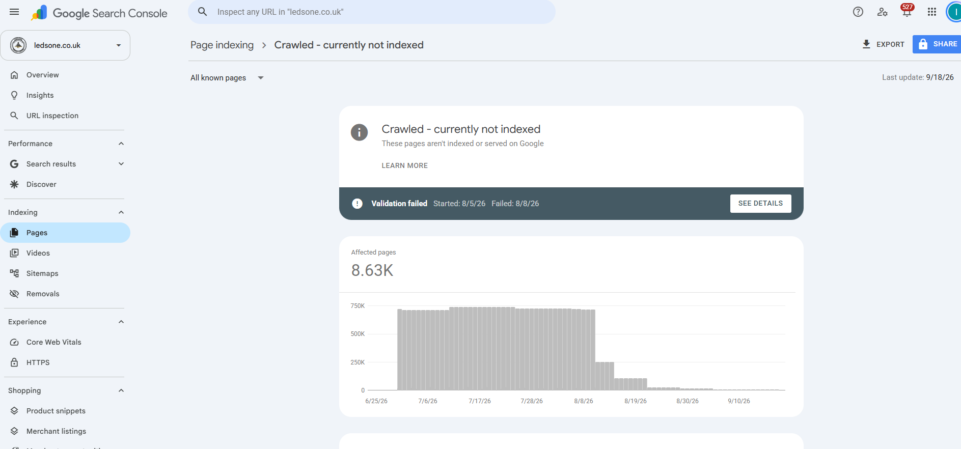
The report shows Last update: 9/18/26. This date is important when interpreting the 8,633 count.

11. What “Last update” means operationally
The Last update date is the date of the report snapshot, not a scheduled future refresh date. GSC does not provide an exact future refresh time. Refreshing the browser does not force a new Page Indexing dataset.
Check periodically (for example, daily or every few days) and compare the Last update date. When it changes, reassess the affected-page count and sample URLs again.

12. Start New Validation — what it does
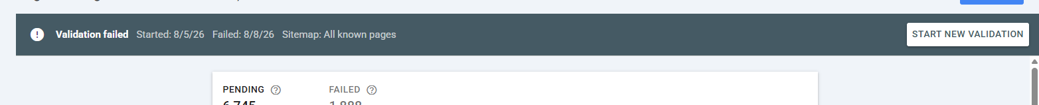
Start New Validation begins a new validation cycle for the issue. Google will recheck affected URLs and report progress/results. It does not immediately index all affected URLs and does not guarantee indexing.
For this investigation, the old validation was not restarted immediately because the report was last updated 18 Sep and multiple sampled URLs were already indexed in current URL Inspection.

13. When to request indexing
- Use Request Indexing for a small number of important URLs after a verified change.
- Do not submit thousands of URLs individually.
- Do not repeatedly request the same URL; repeated requests do not guarantee faster indexing.
- For batch issues, investigate the underlying pattern and allow normal crawling/processing.

14. What to check when a sampled URL is genuinely not indexed
- URL is accessible and returns the intended page.
- Crawl allowed = Yes.
- Page fetch = Successful.
- Indexing allowed = Yes unless exclusion is intentional.
- User-declared canonical is appropriate.
- Google-selected canonical is not unexpectedly different.
- No accidental noindex.
- No unexpected redirect.
- No unwanted robots.txt block.
- Internal links and sitemap signals point to the intended URL where appropriate.
- For international URLs, verify market/language/hreflang configuration.
- Assess whether the page is a useful indexable page rather than a duplicate/low-value URL.

15. Do NOT do these actions blindly
- Do not request indexing for all 8,633 URLs.
- Do not start a new validation simply because an old validation says Failed.
- Do not change canonical tags site-wide without URL-level evidence.
- Do not add noindex just to make the GSC number decrease.
- Do not remove international market URLs such as /pl/, /es/, or /nl/ without checking Shopify Markets and language configuration.
- Do not treat a stale Page Indexing report as proof of the current state of every URL.

16. Decision tree for a new employee
Current evidence | Action
URL from report → URL Inspection says “URL is on Google” | Record current indexed status. No indexing request needed for that sample.
URL from report → not on Google | Open Page indexing details and identify the exact current reason.
Canonical mismatch | Investigate canonical/duplicate/market signals.
Redirect | Check whether the redirect is intentional.
404 | Check whether the URL should exist; do not restore blindly.
5xx | Investigate server/application availability.
Noindex | Confirm whether exclusion is intentional.
Robots.txt block | Confirm whether blocking is intentional before changing robots.txt.
Crawled but not indexed | Check page quality/duplication, canonical, internal links, sitemap and current crawl/indexing signals; sample multiple URLs before deciding on a batch fix.

17. Evidence log template
Field | Record
Date checked
GSC report
Last update date
Affected-page count
Sample URL
Current URL Inspection status
Page indexing reason
Crawl allowed
Page fetch
Indexing allowed
User-declared canonical
Google-selected canonical
Live test result
Action taken
Next check date

18. Current case status — 23 Sep 2026
- Current Page Indexing report: 8,633 Crawled – currently not indexed.
- Report last update shown: 18 Sep 2026.
- Four sampled URLs from the report were inspected and all four were currently indexed.
- Therefore, the 8,633 report should be treated as a batch snapshot, not proof that every listed URL remains unindexed.
- Old validation: started 5 Aug 2026 and failed 8 Aug 2026; it showed 1,888 failed and 6,745 pending.
- Start New Validation was not used during this investigation.
- Next monitoring action: wait for the Page Indexing report to refresh, then reassess the current count and sample current examples.

19. Quick reference — one-page SOP
1. GSC → Indexing → Pages → Crawled – currently not indexed.
2. Record affected count + Last update.
3. Pick representative URLs.
4. URL Inspection each sample.
5. If indexed → record as currently indexed; no request.
6. If not indexed → record exact reason and canonical signals.
7. Test live page when required.
8. Fix root cause only after pattern is confirmed.
9. Request indexing only for appropriate individual URLs.
10. Start New Validation only after a verified current fix.
11. Monitor Last update and re-sample.

